

**Power BI Executive Dashboard Demo**

SandDance Visual

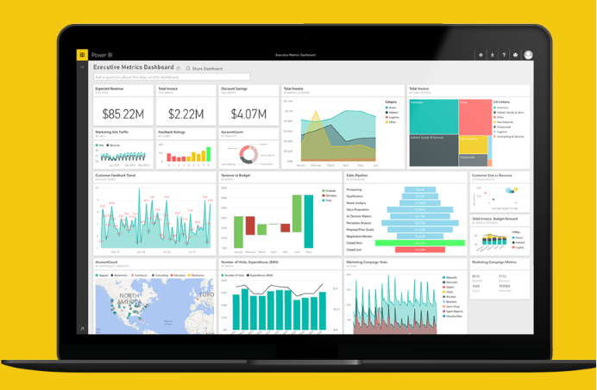

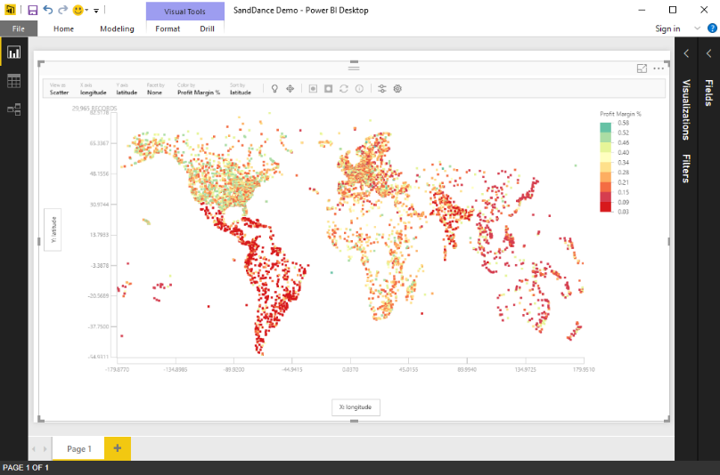

September 2016

# Contents

Contents 2

About this demo 3

Prerequisites 3

Data Visualization with SandDance 5

Conclusion 12

# About this demo

This demo is part of the larger Executive dashboard demo, which illustrates how analytics can help companies to transform their business for success. This demo emphasizes the unique capabilities of the SandDance custom visual in Power BI and how it can it can be used in an enterprise scenario to uncover new insights from large amounts of data.

# Prerequisites

| Prerequisite | Screenshot |
| --- | --- |
| 1. **Prerequisite: Power BI Desktop**   Download and install the latest version of Power BI Desktop from [here](https://powerbi.microsoft.com/en-us/desktop/). |  |
| 1. **Prerequisite**: Download the SandDance visual from the [Power BI Visuals Gallery](https://app.powerbi.com/visuals) or directly from [here](https://app.powerbi.com/visuals/show/SandDance1448759247246). Save the file to a folder on your local machine. |  |
| 1. **Prerequisite**: Import the downloaded SandDance visual file from the Visualizations menu (…) in Power BI Desktop. |  |

# Data Visualization with SandDance

| Steps | Screenshot |
| --- | --- |
| 1. Open the file **SandDance Demo.pbix** file that is provided with this demo in Power BI Desktop. 2. The SandDance visual will appear on the report page (it may take a few seconds for it to be fully rendered). 3. The blue-dotted area represents close to 30,000 sales data points, with each dot representing one row from the sales data set that has been pre-loaded into the PBIX file. 4. Click anywhere outside the blue-dotted area to select the SandDance visual on the report page. |  |
| 1. In the **Visualiziations** pane, on the **Fields** tab, you will notice the fields from the **Sales** table that have already been preselected as **Values** for the SandDance visual:  * **latitude** * **longitude** * **Profit Margin %** * **Product** * **Product Category** * **Channel** * **City** * **Country** * **Customer Segment** * **Region**  1. In the next few steps, we will use these fields in the SandDance visual. |  |
| 1. We will start by using color to further analyze our sales data.  Select **Color by** at the top of the chart, then select **Profit Margin %**. |  |
| 1. The visual will analyze the data points and color them by profit margin. |  |
| 1. To see the profit margin distribution on a 1-10 scale, click on the **Profit Margin %** legend on the right 2. In the menu that opens, select **Palette**, and choose **Spectral**. |  |
| 1. Close the menu. 2. The chart will look as shown on the right, with a 10 scale coloring of profit margins for every data point. |  |
| 1. To sort the data points, expand the **Sort by** menu, then select **Profit Margin %**. |  |
| 1. The chart is now showing the data points with the lowest profit margins at the bottom, colored in red and the data points with the highest profit margin at the top, in green. |  |
| 1. Expand the **View as** menu of the chart to change from a **Grid** to a **Column** chart. |  |
| 1. Expand the **X axis** menu of the chart to and select **Region**. |  |
| 1. The chart is now showing the profit margins for each region.   Insight: North America has higher product margins compared to Latin America & Carribbean. |  |
| 1. Expand the **View as** menu of the chart to change from a **Column** to a **Scatter** chart. |  |
| 1. Expand the **X axis** menu of the chart to and select **longitude**. |  |
| 1. Expand **View As** menu and click on Shapes 2. Change the **Shape size** to **2**. 3. Close the panel. |  |
| 1. The chart is now showing each profit margin data point on a map.   Insight: The South America and Asia Pacific appear more red, indicating that they have lower profit margins than other part of the world. |  |
| 1. With your mouse, click near the very top left area of the map, then hold the mouse button to draw a selection rectangle over North America. Repeat this step if needed. 2. Select the **Isolate the selected items** button at the top of the chart. 3. The chart will now render the isolated data points only. |  |
| 1. Expand the **View as** menu of the chart to change from a **Scatter** to a **Column** chart. |  |
| 1. Expand the **X axis** menu of the chart to and select **Product**. 2. Expand the **Sort by** menu, then select **Profit Margin %**. |  |
| Insight: Furniture products, candles, cocktail glasses… show higher profit margins in North America.   1. Use **Save As** file to save the Power BI Desktop file to your local machine (so it won’t overwrite the original file for future presentations). |  |

# Conclusion

We hope you enjoyed this demonstration about using the SandDance visual and its unique capabilities in enterprise scenario to uncover new insights from large amounts of data.

©2016 Microsoft Corporation. All rights reserved.

By using this demo/lab, you agree to the following terms:

The technology/functionality described in this demo/lab is provided by Microsoft Corporation for purposes of obtaining your feedback and to provide you with a learning experience. You may only use the demo/lab to evaluate such technology features and functionality and provide feedback to Microsoft. You may not use it for any other purpose. You may not modify, copy, distribute, transmit, display, perform, reproduce, publish, license, create derivative works from, transfer, or sell this demo/lab or any portion thereof.

COPYING OR REPRODUCTION OF THE DEMO/LAB (OR ANY PORTION OF IT) TO ANY OTHER SERVER OR LOCATION FOR FURTHER REPRODUCTION OR REDISTRIBUTION IS EXPRESSLY PROHIBITED.

THIS DEMO/LAB PROVIDES CERTAIN SOFTWARE TECHNOLOGY/PRODUCT FEATURES AND FUNCTIONALITY, INCLUDING POTENTIAL NEW FEATURES AND CONCEPTS, IN A SIMULATED ENVIRONMENT WITHOUT COMPLEX SET-UP OR INSTALLATION FOR THE PURPOSE DESCRIBED ABOVE. THE TECHNOLOGY/CONCEPTS REPRESENTED IN THIS DEMO/LAB MAY NOT REPRESENT FULL FEATURE FUNCTIONALITY AND MAY NOT WORK THE WAY A FINAL VERSION MAY WORK. WE ALSO MAY NOT RELEASE A FINAL VERSION OF SUCH FEATURES OR CONCEPTS. YOUR EXPERIENCE WITH USING SUCH FEATURES AND FUNCITONALITY IN A PHYSICAL ENVIRONMENT MAY ALSO BE DIFFERENT.

**FEEDBACK**. If you give feedback about the technology features, functionality and/or concepts described in this demo/lab to Microsoft, you give to Microsoft, without charge, the right to use, share and commercialize your feedback in any way and for any purpose. You also give to third parties, without charge, any patent rights needed for their products, technologies and services to use or interface with any specific parts of a Microsoft software or service that includes the feedback. You will not give feedback that is subject to a license that requires Microsoft to license its software or documentation to third parties because we include your feedback in them. These rights survive this agreement.

MICROSOFT CORPORATION HEREBY DISCLAIMS ALL WARRANTIES AND CONDITIONS WITH REGARD TO THE DEMO/LAB, INCLUDING ALL WARRANTIES AND CONDITIONS OF MERCHANTABILITY, WHETHER EXPRESS, IMPLIED OR STATUTORY, FITNESS FOR A PARTICULAR PURPOSE, TITLE AND NON-INFRINGEMENT. MICROSOFT DOES NOT MAKE ANY ASSURANCES OR REPRESENTATIONS WITH REGARD TO THE ACCURACY OF THE RESULTS, OUTPUT THAT DERIVES FROM USE OF DEMO/ LAB, OR SUITABILITY OF THE INFORMATION CONTAINED IN THE DEMO/LAB FOR ANY PURPOSE.

**DISCLAIMER**

This demo/lab contains only a portion of new features and enhancements in Microsoft Power BI. Some of the features might change in future releases of the product. In this demo/lab, you will learn about some, but not all, new features.